Fast**National University of Computer & Emerging Sciences, Karachi  
Assignment 1 (Spring-2023) -Solution**

Q1:

www.xyz.com (it is an e-commerce website)

a)       Using this website, customers will be able to browse and purchase products online.

b)      Goal is to increase online sales by 10%, one of your objectives might be to increase website traffic by 20%.

(If you can reach that objective, you are well on achieving your goal).

c)       Scope :

* Design and Development: The website should be designed with a user-friendly interface that is visually appealing, easy to navigate and optimized for mobile devices. It should also have the necessary features such as search functionality, shopping cart, checkout process, and payment gateway integration.
* Product Catalog: The website should have a catalog of products that are categorized and easy to search. Each product should have detailed information including price, images, reviews, and ratings.
* Inventory Management: The website should have a backend system to manage inventory, stock levels, and product availability. This helps in avoiding overselling and stockouts.
* Order Management: The website should have a system to manage orders, tracking, and shipment. It should also provide real-time updates on order status and shipment tracking.
* Payment Gateway Integration: The website should integrate with popular payment gateways to enable easy and secure online transactions. It should also have support for multiple currencies and payment methods.
* Customer Support: The website should have a customer support system to handle inquiries, complaints, and feedback. This could be through email, phone, chat, or a dedicated support portal.

d)       WBS

1.0: Shopping website (xyz.com)

1.1: Design and Development

1.1.1: Website Design

1.1.2: Develop website wireframes and mockups

1.1.3: Create website graphics and visual design

1.1.4: Develop website layout and navigation

1.1.5: Test website usability and accessibility

             1.2: Website Development

          1.2.1: Develop website front-end code (HTML, CSS, JavaScript)

          1.2.2: Develop website back-end code (server-side scripting, database integration)

          1.2.3: Develop website integration with third-party tools and services (e.g., payment      gateway)

                        1.2.4Test website functionality and performance

          1.3: Product catalog

1.3.1: Develop product categorization and organization

1.3.2: Develop product information and attributes

1.3.3: Develop product search and filtering

1.3.4: Test product catalog usability and functionality

        1.4: Inventory Management

1.4.1: Develop inventory tracking and reporting

1.4.2: Develop inventory alerts and notifications

1.4.3: Develop inventory management rules and policies

1.4.4: Test inventory management functionality and accuracy

                1.5: Order Management

1.5.1: Develop order processing and fulfillment workflows

1.5.2: Develop order tracking and shipping notifications

1.5.3: Develop customer return and refund policies and procedures

1.5.4: Test order management functionality and accuracy

            1.6: Payment Gateway Integration

                         1.6.1: Develop payment processing workflows and policies

                           1.6.2:  Develop website security policies and procedures

 1.6.3: Test website security and payment functionality

              1.7: Customer support

                       1.7.1: Develop customer support knowledge base and FAQs

Q2:

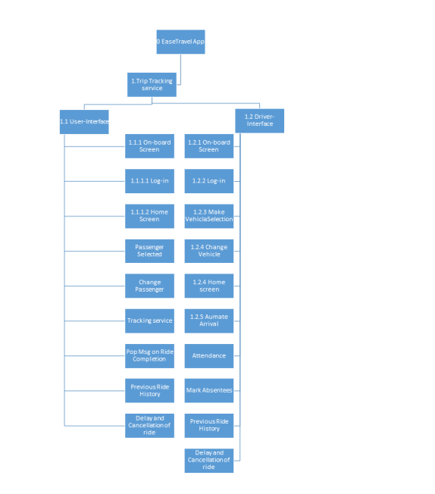

Q3:

